Understanding Tokenization and Hugging Face Transformers

How Hugging Face Transformers Complete Text
Ever wondered how artificial intelligence can seamlessly continue your thoughts? Hugging Face Transformers demonstrate this capability through text completion, transforming prompts into fluent continuations. Below, we break down the steps involved in this process:
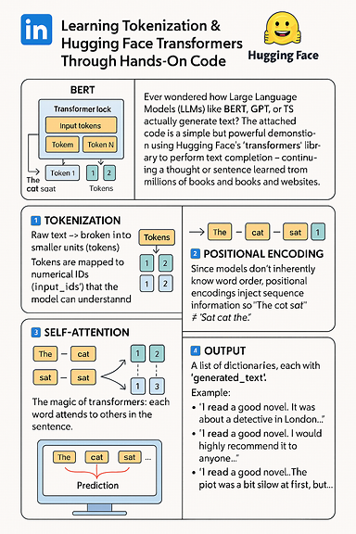

Step 1: Tokenization
The process begins by splitting raw text into tokens, which can be words or subwords. These tokens are then mapped to numerical IDs, referred to as input_ids. This step bridges the gap between human language and machine understanding, enabling the model to process textual information.
Here explains tokenization of simple text - Hello, how are you?
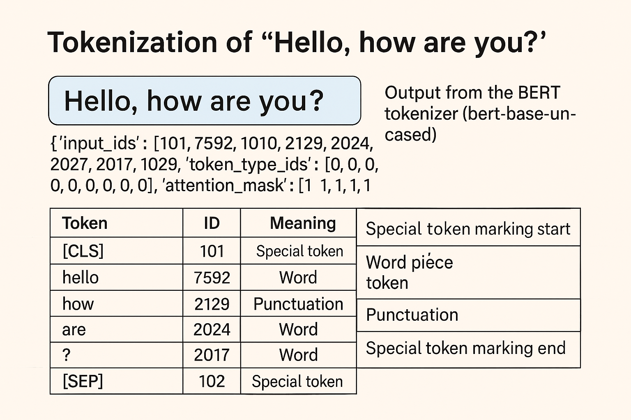
token_type_ids
Used in sentence-pair tasks to distinguish between Sentence A and Sentence B.
- All 0s → This is a single sentence input.
3️⃣ attention_mask
Tells the model which tokens to attend to.
- 1 = Focus on this token
- 0 = Ignore (e.g., padding)

Step 2: Positional Encoding
Transformers do not inherently understand word order. Positional encodings are introduced to provide sequence information, ensuring that phrases like "The cat sat" are distinguished from "Sat cat the." This encoding preserves the meaning conveyed by word order.

Step 3: Self-Attention
Each word in a sentence attends to other words, capturing context dynamically. For example, the word “novel” may be interpreted as “detective in London” depending on its context. Self-attention is a core mechanism that enables transformers to understand relationships within sentences.

Step 4: Prediction
The model predicts the next most likely tokens, resulting in multiple possible continuations. This step showcases the model’s creativity and diversity in generating text outputs.

Step 5: Output
The final result is a list of dictionaries containing generated_text. Example outputs include:
- “I read a good novel. It was about a detective in London…”
- “I read a good novel. I would highly recommend it to anyone…”
- “I read a good novel. The plot was a bit slow at first, but…”
By running this code, you experience the full pipeline of modern natural language processing (NLP): Tokenization, Positional Encoding, Self-Attention, Prediction, and Output. Hugging Face simplifies the process, allowing users to focus on learning key concepts without reinventing foundational tools.

Overview of Hugging Face and Transformers

What Is Hugging Face?
Hugging Face is an open-source platform and community dedicated to building, sharing, and collaborating on machine learning models, particularly transformers used in NLP, computer vision, and audio. The platform places a strong emphasis on NLP, generative AI, and computer vision and provides resources like the Model Hub, Datasets Hub, and Spaces for hosting machine learning demos.

What Are Hugging Face Transformers?
Hugging Face Transformers offer a unified API for accessing thousands of pre-trained models, including BERT, GPT, and T5. This makes advanced AI accessible to developers and researchers for tasks in NLP and beyond. The library includes tokenizers to prepare raw text for model input and simplifies workflows for text classification, translation, question answering, and text generation.

Use Cases
- Chatbots and virtual assistants
- Text classification and sentiment analysis
- Machine translation
- Named entity recognition
- Summarization and question answering

Popular Models Supported
- BERT – Bidirectional encoder for understanding context
- GPT-2/GPT-3 – Generative models for text completion
- T5 – Text-to-text transformer for multiple NLP tasks
- RoBERTa, DistilBERT, XLNet – Variants optimized for speed, accuracy, or size

Key Features of Hugging Face Transformers
Component | Purpose
AutoModel | Load pre-trained models with minimal setup
AutoTokenizer | Convert raw text into tokens suitable for transformer input
Trainer | Simplifies training, evaluation, and fine-tuning
Pipeline | High-level API for tasks like sentiment analysis, translation, summarization
Model Hub | Central repository for sharing and downloading models

Integration Highlights
- Compatible with PyTorch, TensorFlow, and JAX
- Works with ONNX, DeepSpeed, and Accelerate for production environments
- Hugging Face Hub supports versioning, collaboration, and deployment

